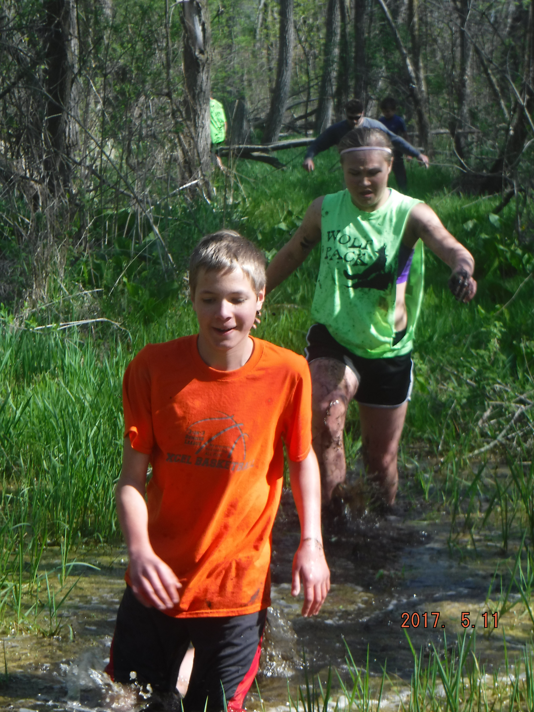
If you can jog or walk 3 miles, can do a few pushups, have confidence and want to have fun. Then you can do this course.
Conquer 20+ obstacles with friends and family through the swamp while you climb, crawl, walk and jump in mud pits. You will climb over walls, run up 15ft slanted walls, cargo nets, beams, tunnels, tires and hills.

Who is this for? Family reunions, gatherings, Scouts, Bachelor/ette Parties, Birthday Parties, Team building for sport groups,

How Hard is it? We designed our obstacles so everyone can do them and a course that will challenge everyone. We will help you in every way to conquer the obstacles. If you need to pass one, no penalty applied. There is no map to view on our course, because we add obstacles every year.

What to wear & bring? Wear clothes that are not very loose fitting, to prevent water log clothing, and wear shoes that can get muddy. Be sure they can tie, there have been a few lost in the pits.
Bring a towel and change of clothes, socks and shoes.

What to expect! We start off with a game to get everyone warmed up. You can bring water bottles, sweatshirts, cameras but they will stay up at camp while we run the course. If you need inhalers or anything, I will carry them with me in my awesome fanny pack.
When we return, there is a clean up tubs station, towels available, tent to change in and food of energy ball bites and lemonade.
I will take pictures and post them on my site. Please tag yourself in them, leave a comment of your experience and then you may choose any pictures of your choice to have for you keeping and to share.

Souvenirs available: T-shirt $8, Frisbees, pens, water bottle, stickers, karabiners, bottle openers, koozies, each $2. PKG: Tshirt + 2 small souvenirs $10
Thank you for your extra support and advertising.

Other options:
* Run a benefit here for a family member or friend. Please ask for further information.
* Repeat runs. Bring a new group of 4 or more and receive $5 off your own ticket.
* Run the obstacle multiple times in a row! Only $10 extra.

