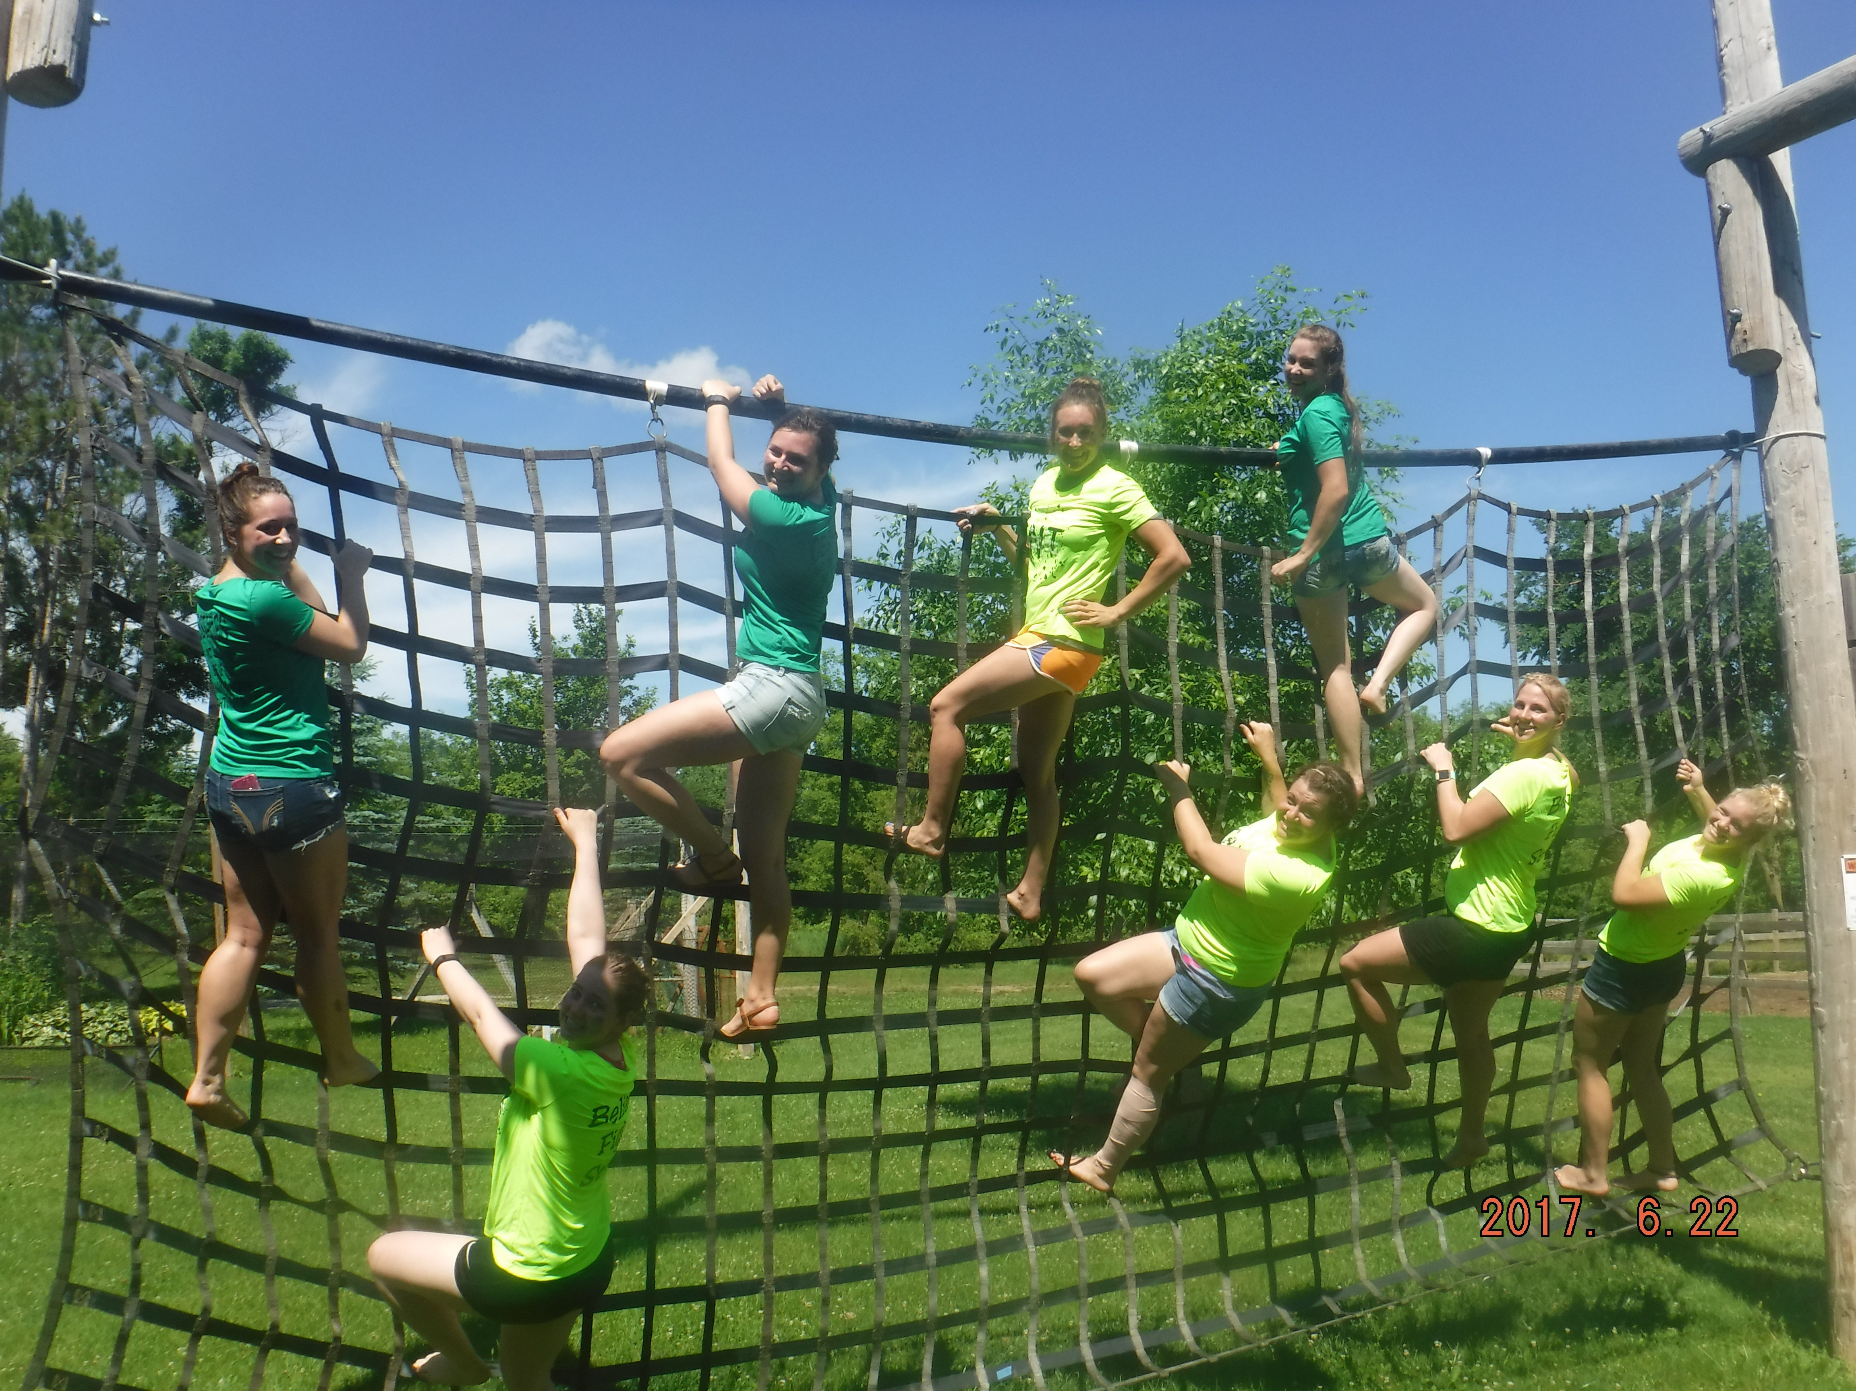
Swamp Run Fundraiser Benefit Opportunity

We are here to have fun and be open to help everyone around us. We periodically hold runs to help raise $ for local areas such as saving paws, food pantries, and families of casualty.

We also offer the opportunity for you to run the obstacles for a benefit for a friend or family member in need also a fundraiser for your school event or program.

What to expect.
* The price is determined upon us at the time of meeting. What we ask is that we receive $10-12/per person.
For example, charge $30/person to run, option to do group discounts example family of 4/5 for $100.

* Each group Starts in Octoball pit play 2 games and then the leader takes them through the course.

* I ask that your group would help in anyway possible to make sure each group of people go through the course safely. We are only a group of 5. Look for people to lead each group through.

Options:
- You may offer to serve food here but it is done on a donation basis. I can offer to make it here and you then reimburse me for the cost plus $60 for prepping it. You keep the rest of the making.
- We may run the obstacle for a set number of hours, example 9-11/12pm. This way people can spread out a bit and its not 100 at one time. Groups 10-20 will run through together as they arrive.

Extras:
- I have souvenirs here with Swamp run on them and I would offer them to sell for extra profit for me.
- You may make shirts to support a cause but I ask that my name and logo is on it as well. You may include them in the price as well.
Any other questions or offers or thoughts please lmk. We want this to be a fun reoccurring opportunity for the community and you. We are willing to work with you so please just ask.

